How to Download “Attendance”
Note: Make sure you are logged in to BrightSpace (ask a campus Principal to help you with this).
Download all “Attendance” files (in .csv format) and copy to USB’s “Attendance” folder.

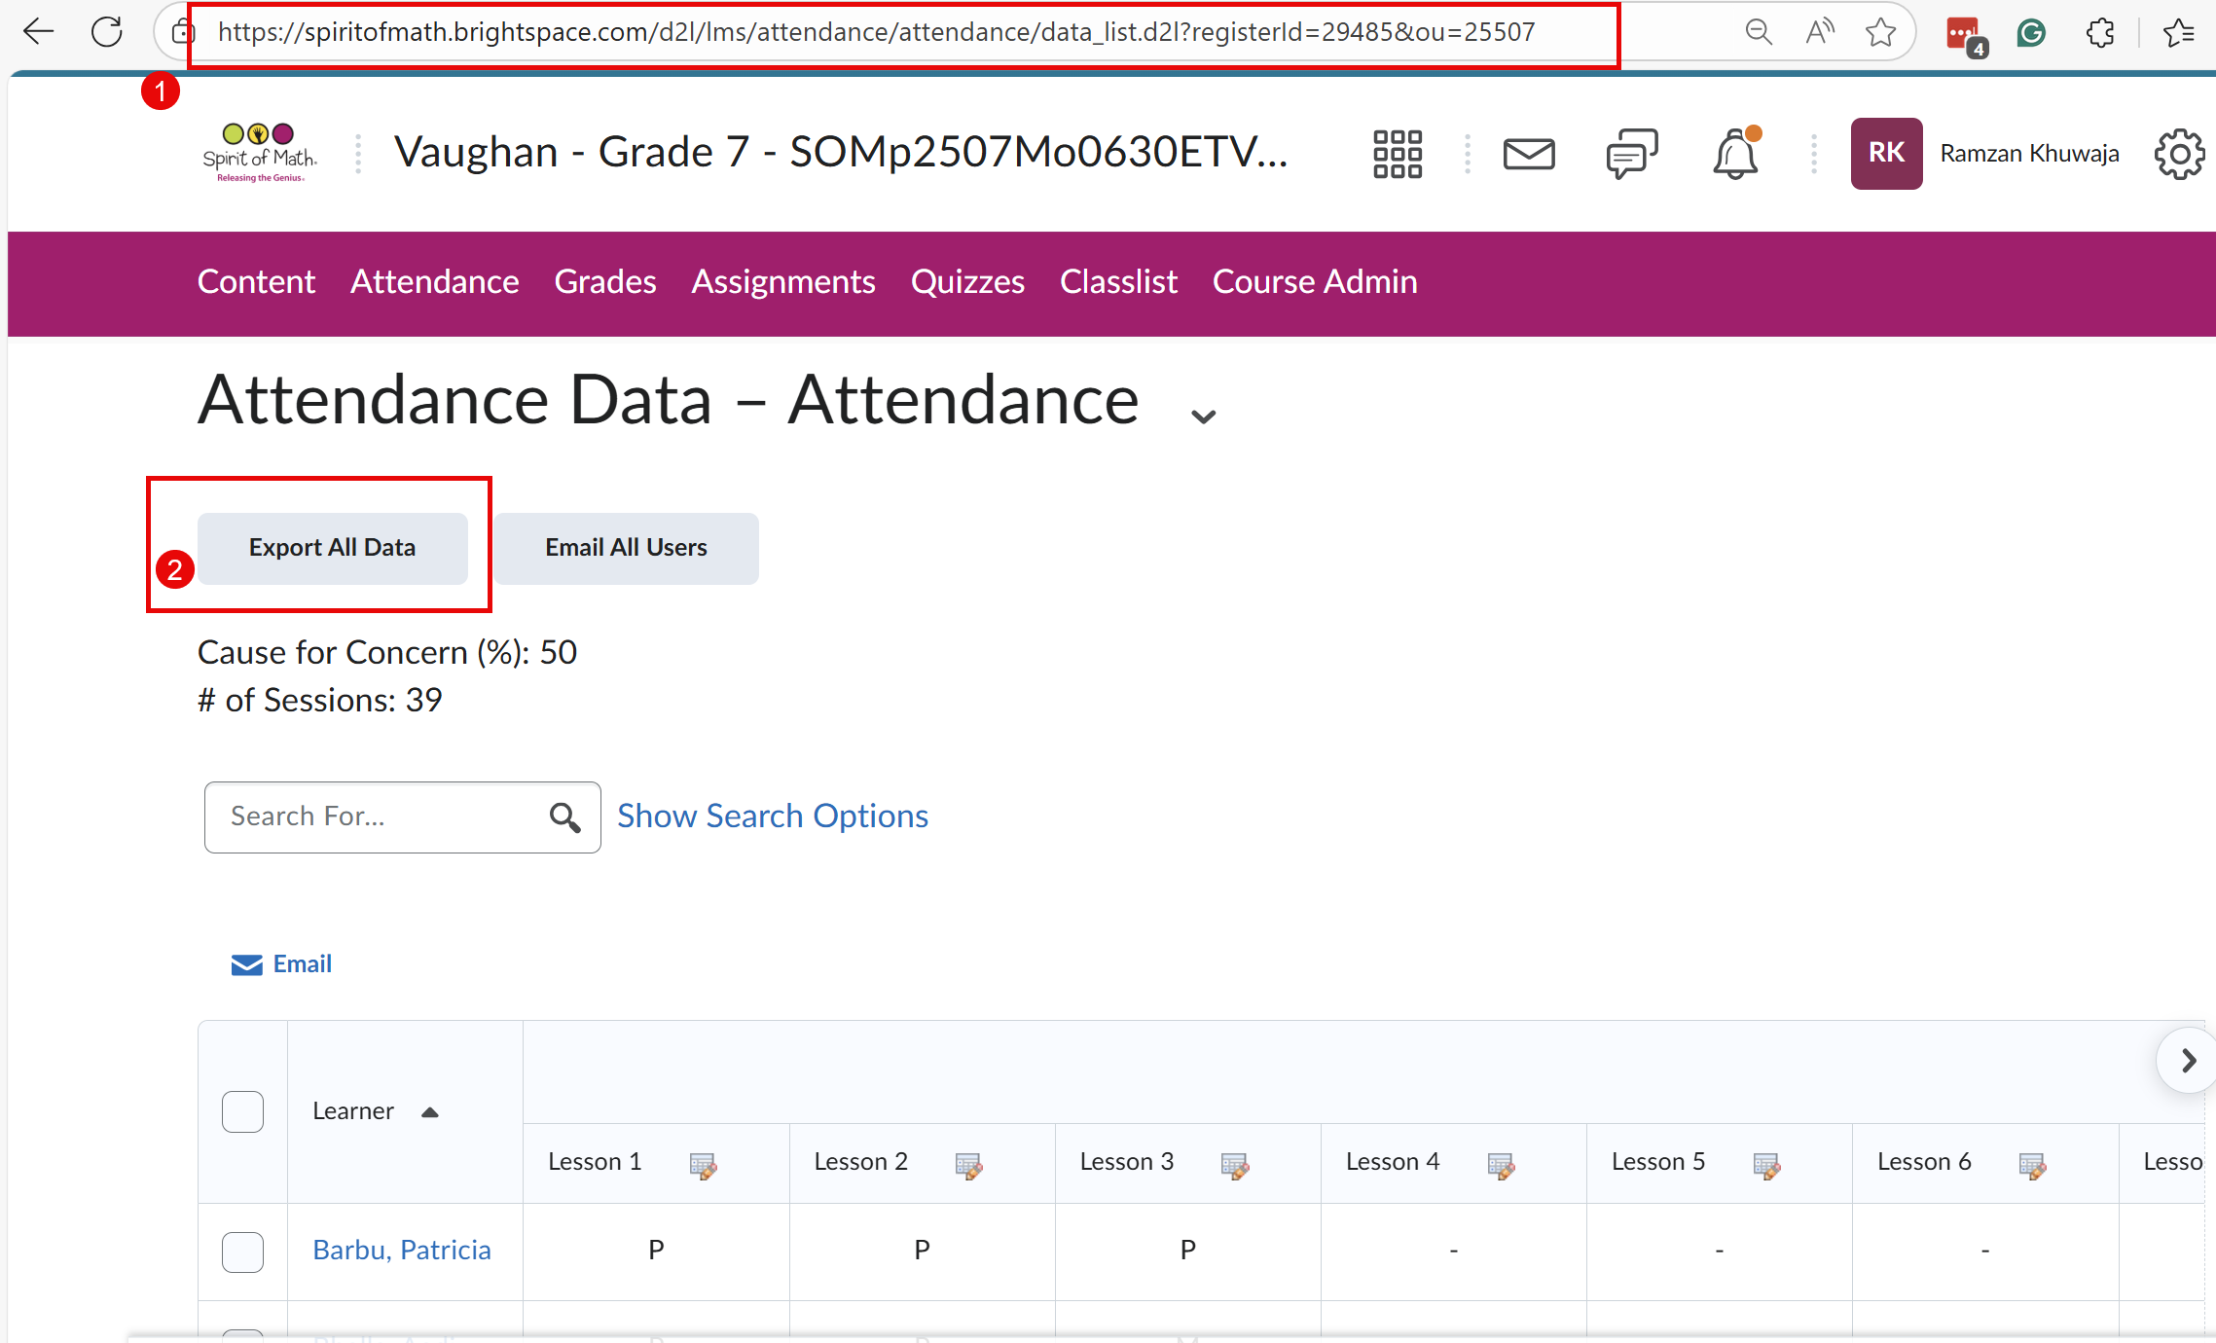
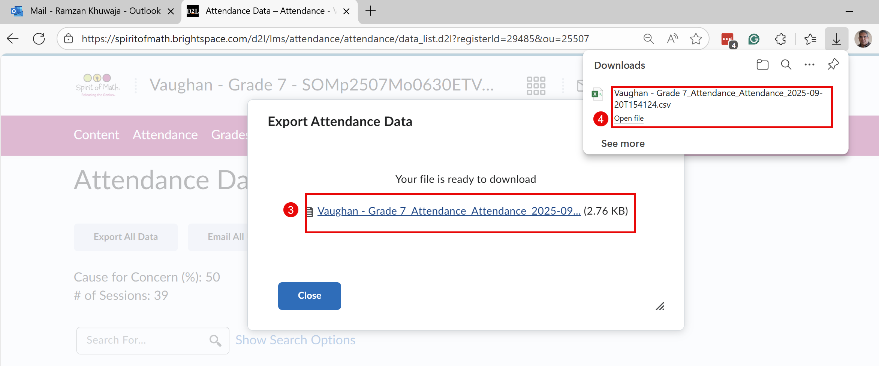

How to Download “Grades”
Note: Make sure you are logged in to BrightSpace (ask a campus Principal to help you with this).
Download all “Grades” files (in .csv format) and copy to USB’s “Grades” folder.

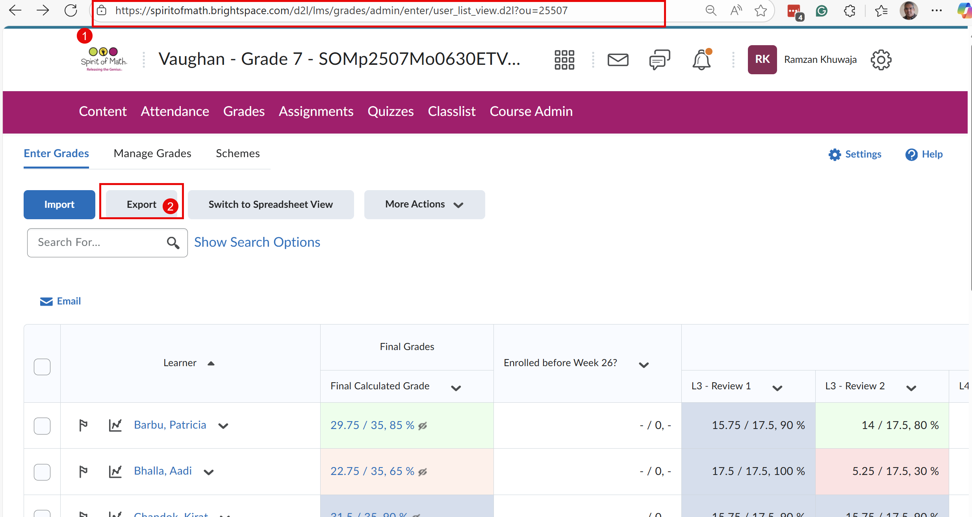

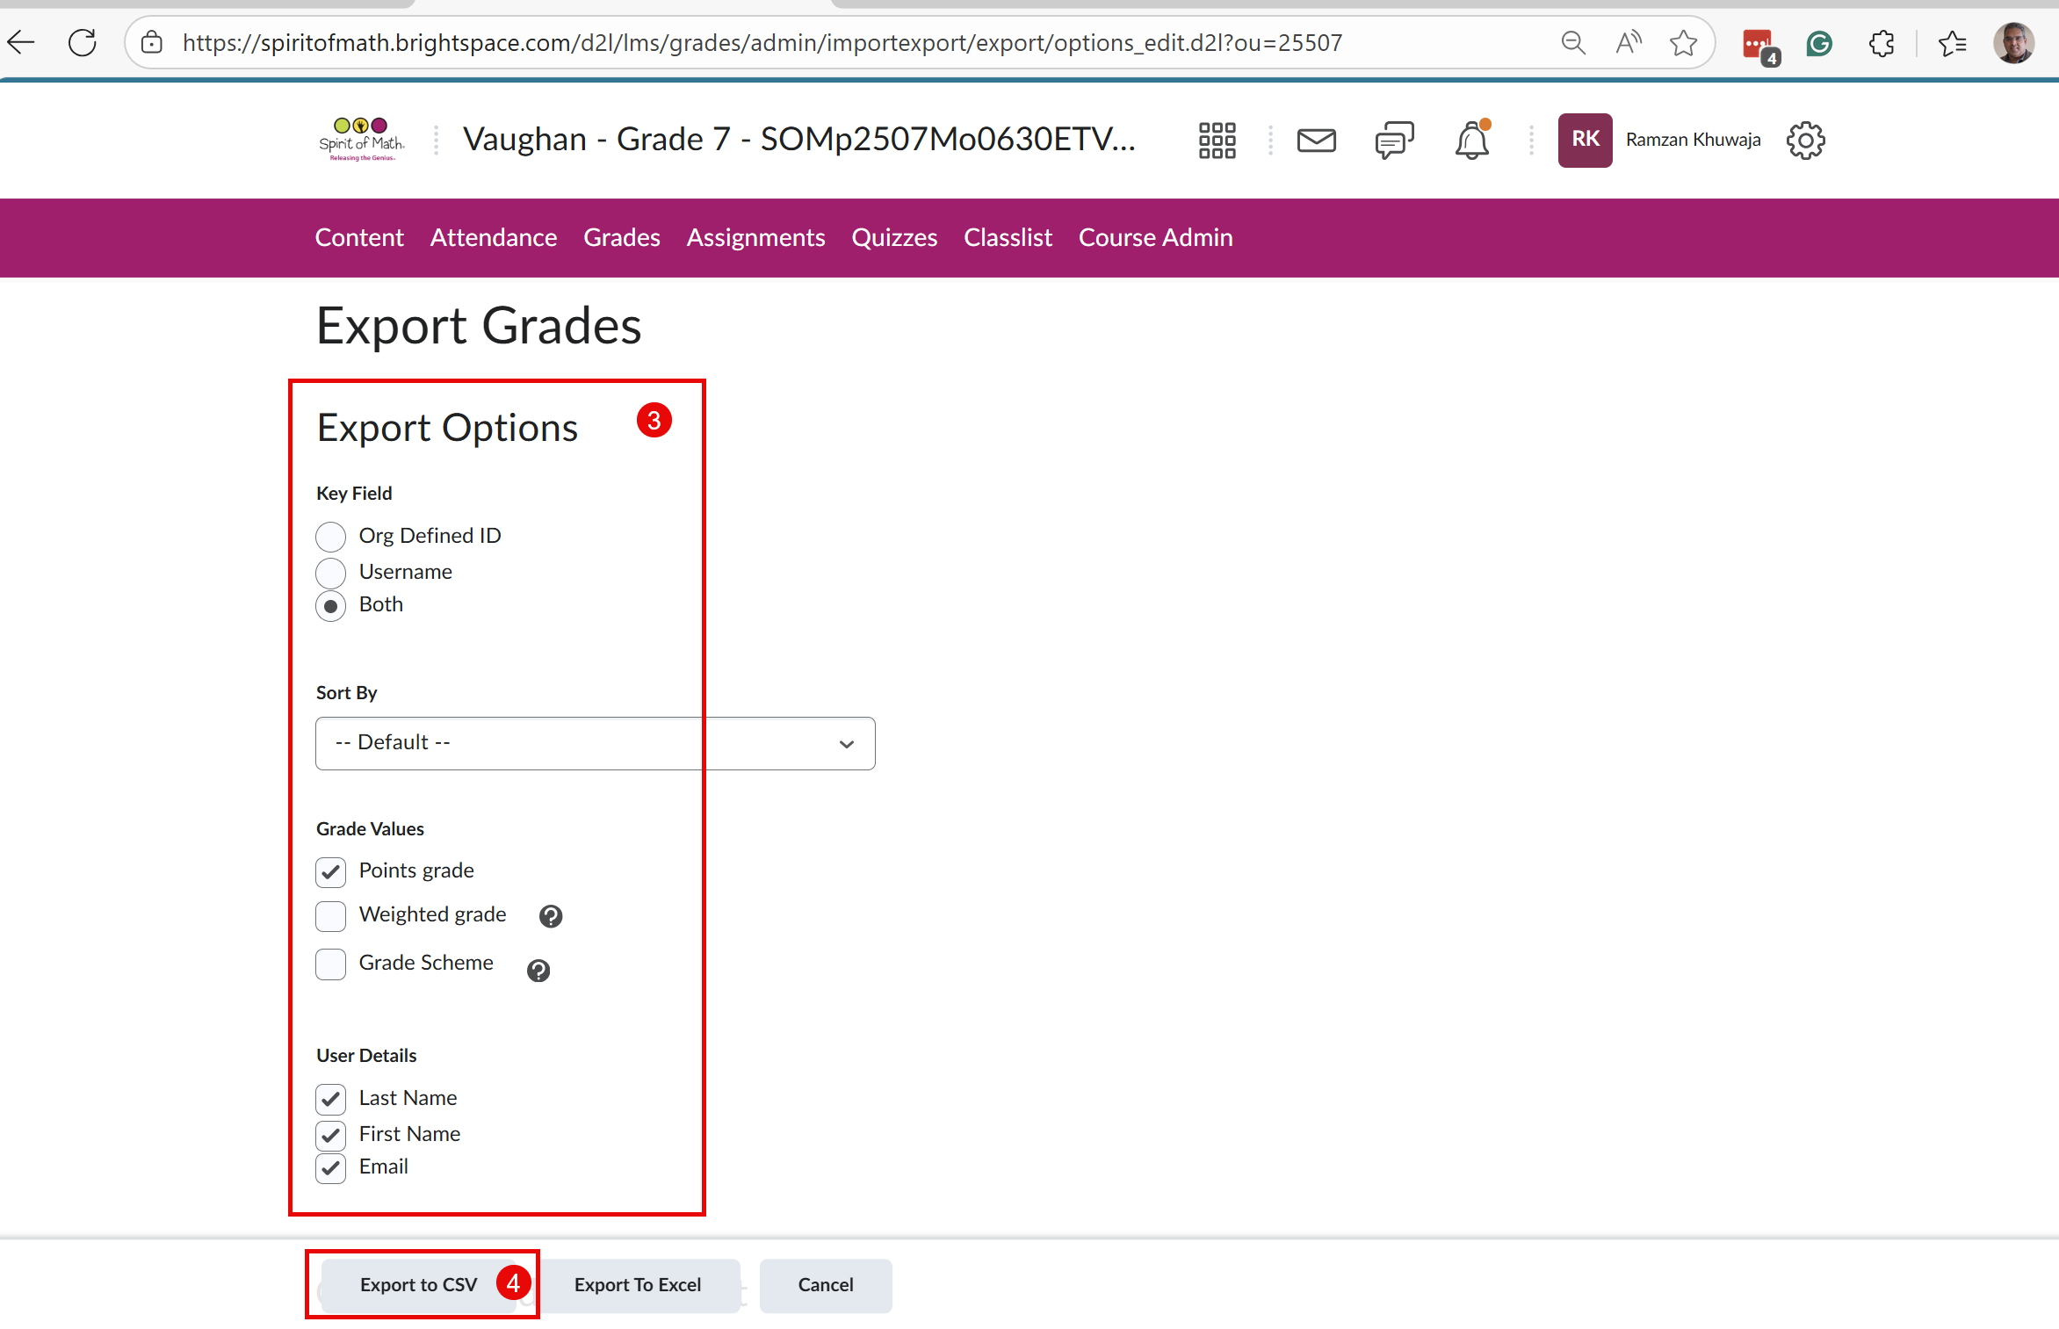
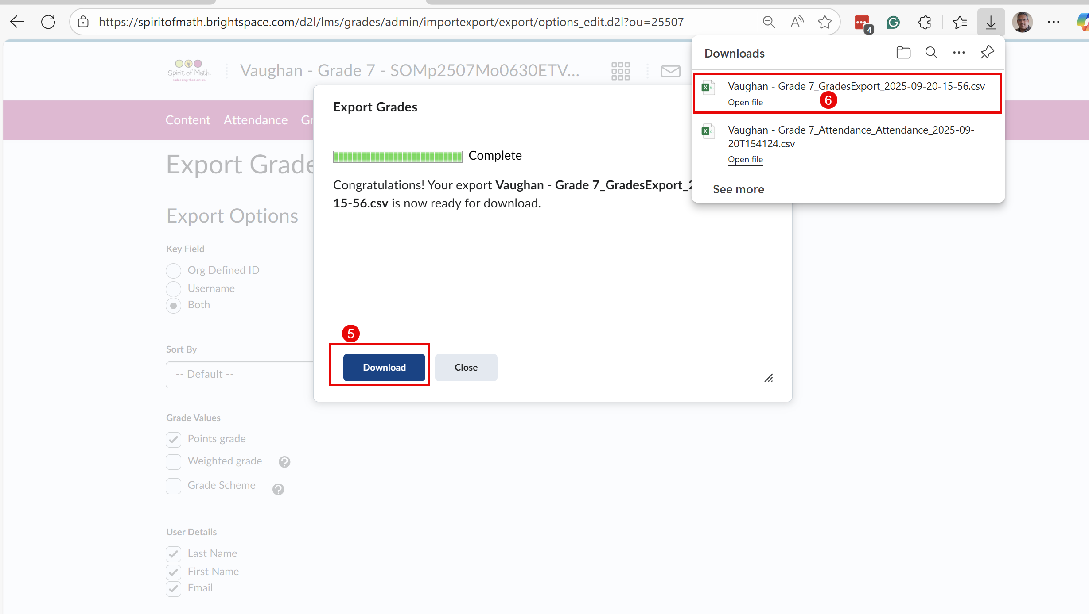

How to Download “ClassList”
Note: Make sure you are logged in to BrightSpace (ask a campus Principal to help you with this).
Download all “ClassList” files (in .html format) and copy to USB’s “ClassList” folder.
To save a file, press Control + s on a Windows or Chromebook laptop.
